March 23, 2023

Suntuity Solar

2137 Route 35

Holmdel, NJ 07733

Re: Engineering Services

Smith Residence

11720 Drexwood Drive, Princess Anne MD

12.800 kW System

To Whom It May Concern:

We have received information regarding solar panel installation on the roof of the above referenced structure. Our evaluation of the structure is to verify the existing capacity of the roof system and its ability to support the additional loads imposed by the proposed solar system.

1. ***Site Assessment Information***
2. Site visit documentation identifying attic information including size and spacing of framing for the existing roof structure.
3. Design drawings of the proposed system including a site plan, roof plan and connection details for the solar panels. This information will be utilized for approval and construction of the proposed system.
4. ***Description of Structure:***

***Roof Framing:*** Rafters, 2x8 dimensional lumber at 16” on center.

***Roof Material:*** Composite Asphalt Shingles

***Roof Slopes:*** 34 degrees

***Attic Access:*** Accessible

***Foundation:*** Permanent

1. ***Loading Criteria Used***

* **Dead Load**
  + Existing Roofing and framing = 7 psf
  + New Solar Panels and Racking = 3 psf
  + TOTAL = 10 PSF
* **Live Load** = 20 psf (reducible) – 0 psf at locations of solar panels
* **Ground Snow Load** = 25 psf
* **Wind Load** based on ASCE 7-16
  + Ultimate Wind Speed = 120 mph (based on Risk Category II)
  + Exposure Category B

*Analysis performed of the existing roof structure utilizing the above loading criteria is in accordance with the Maryland Residential Code (2018 International Residential Code), including provisions allowing existing structures to not require strengthening if the new loads do not exceed existing design loads by 105% for gravity elements and 110% for seismic elements. This analysis indicates that the existing framing will support the additional panel loading without damage, if installed correctly.*

1. ***Solar Panel Anchorage***
2. The solar panels shall be mounted in accordance with the most recent EcoFasten Solar installation manual. If during solar panel installation, the roof framing members appear unstable or deflect non-uniformly, our office should be notified before proceeding with the installation.
3. The maximum allowable withdrawal force for a 5/16” lag screw is 229 lbs per inch of penetration as identified in the National Design Standards (NDS) of timber construction specifications. Based on a minimum penetration depth of 2½”, the allowable capacity per connection is greater than the design withdrawal force (demand). Considering the variable factors for the existing roof framing and installation tolerances, the connection using one 5/16” diameter lag screw with a minimum of 2½” embedment will be adequate and will include a sufficient factor of safety.
4. Considering the wind speed, roof slopes, size and spacing of framing members, and condition of the roof, the panel supports shall be placed no greater than 48” on center.

Based on the above evaluation, this office certifies that with the racking and mounting specified, the existing roof system will adequately support the additional loading imposed by the solar system. This evaluation is in conformance with the Maryland Residential Code (2018 IRC), current industry standards and practice, and is based on information supplied to us at the time of this report.

Should you have any questions regarding the above or if you require further information do not hesitate to contact me.

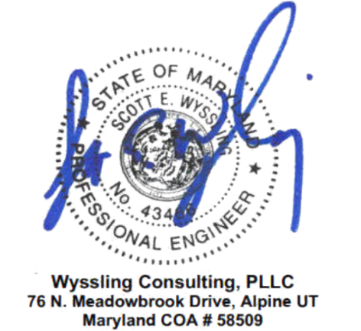

Very truly yours,

Scott E. Wyssling, PE

Maryland License No. 43466

COA #58509